**Week1**

**Exercise 1: Introduction to Version Control**

**Objective:**

Initialize a new Git repository and commit your first file.

**Instructions:**

1. Create a new directory for your project.
2. Navigate into the directory.
3. Initialize a new Git repository in the directory.
4. Create a new file named file1.txt and add some content to it.
5. Add the file to the staging area.
6. Commit the file with a commit message.

PS E:\VIT\vit2024-2025\Cognizant\Round3\DNDeepSkilling> git init

Initialized empty Git repository in E:/VIT/vit2024-2025/Cognizant/Round3/DNDeepSkilling/.git/

PS E:\VIT\vit2024-2025\Cognizant\Round3\DNDeepSkilling> echo demo.txt

demo.txt

PS E:\VIT\vit2024-2025\Cognizant\Round3\DNDeepSkilling> git add .

PS E:\VIT\vit2024-2025\Cognizant\Round3\DNDeepSkilling> git commit

Aborting commit due to empty commit message.

PS E:\VIT\vit2024-2025\Cognizant\Round3\DNDeepSkilling> git commit -m "first commit"

[master (root-commit) a6c06dc] first commit

1 file changed, 1 insertion(+)

create mode 100644 Task1/file1.txt

PS E:\VIT\vit2024-2025\Cognizant\Round3\DNDeepSkilling> git log

commit a6c06dc4ca1fc6710e50ea81afbc2f78fb85de81 (HEAD -> master)

Author: Sarika <sarikav2003@gmail.com>

Date: Fri Aug 2 16:44:58 2024 +0530

first commit

**Exercise 2: Understanding Git**

**Objective:**

Clone an existing repository and explore its history.

**Instructions:**

1. Clone a public repository from a platform like GitHub.
2. Navigate into the cloned repository.
3. Check the commit history.
4. Show changes introduced by a specific commit.

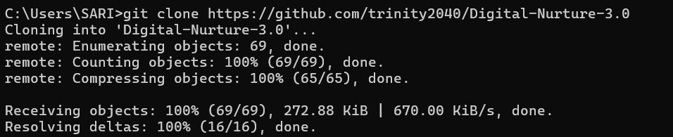

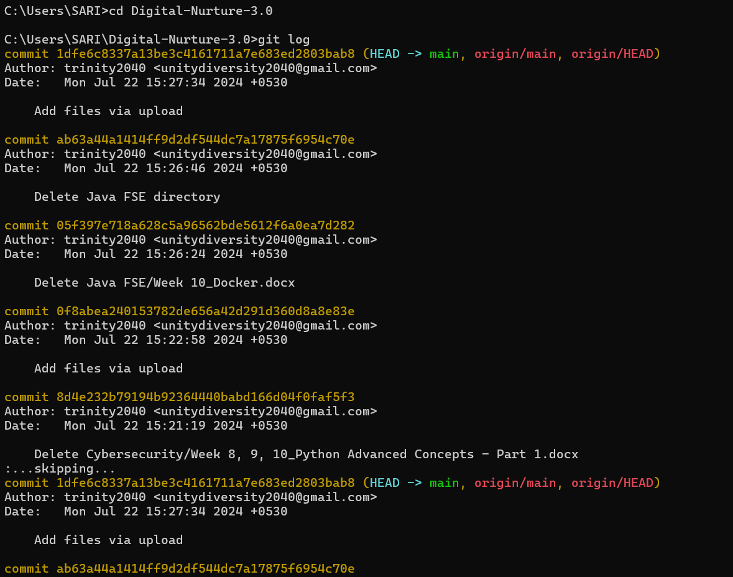

**Exercise 3: Setting Up Git**

**Objective:**

Set up Git configuration and verify it.

**Instructions:**

1. Set your username for Git.
2. Set your email for Git.
3. Verify your configuration settings.





**Exercise 4: Basic Git Commands**

**Objective:**

Practice basic Git commands by modifying files and tracking changes.

**Instructions:**

1. Create a new file named file2.txt and add some content to it.
2. Add the file to the staging area.
3. Commit the new file with a commit message.
4. Modify the existing file1.txt and add more content to it.
5. Add the modified file to the staging area.
6. Commit the changes with a commit message.
7. View the current status of your repository.
8. View the differences between your working directory and the repository.

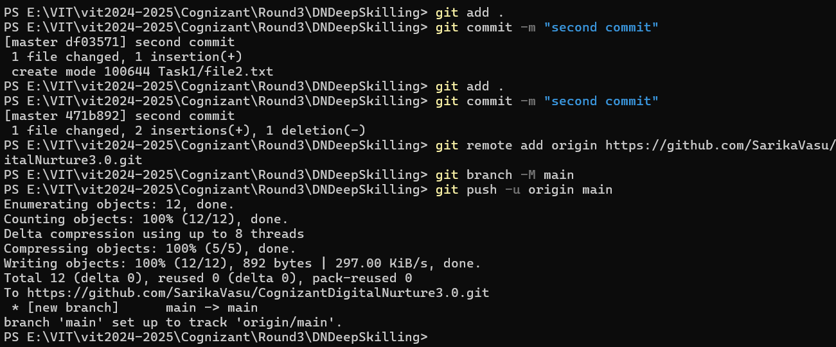

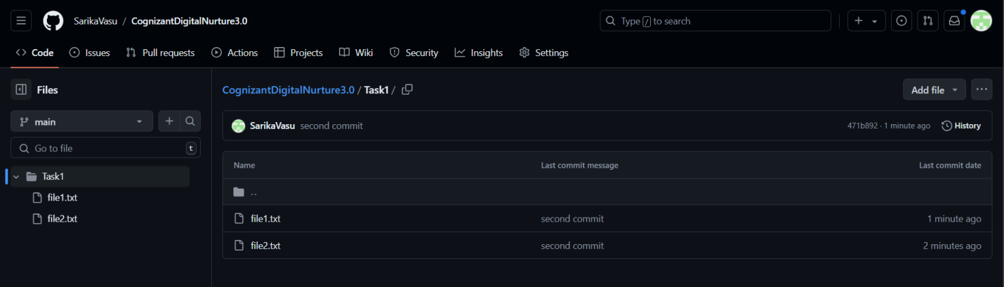

**Exercise 5: Branching and Merging**

**Objective:**

Create a new branch, make changes, and merge it back to the main branch.

**Instructions:**

1. Create a new branch named new-feature.
2. Switch to the new branch (if not already switched).
3. Create a new file named feature.txt and add some content to it.
4. Add the file to the staging area.
5. Commit the new file with a commit message.
6. Switch back to the main branch.
7. Merge the new-feature branch into the main branch.
8. Resolve any conflicts if they arise and commit the merge.

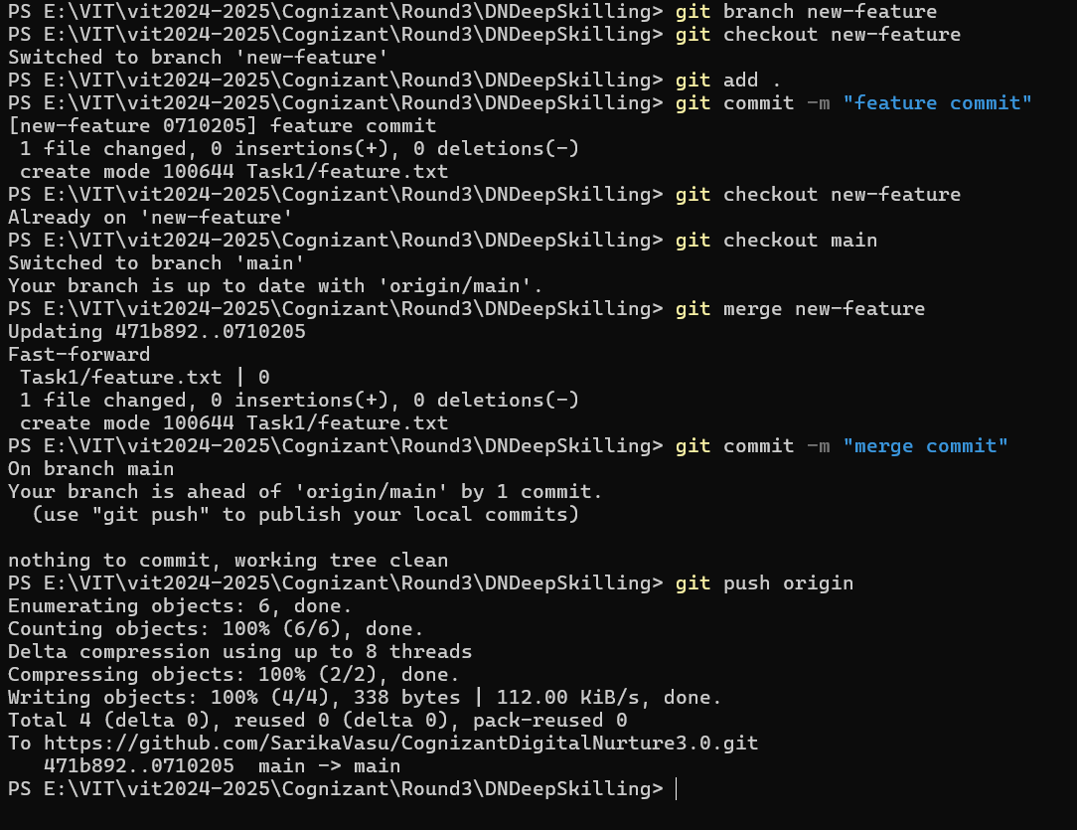

**Exercise 6: Remote Repositories**

**Objective:**

Add a remote repository and push your local changes.

**Instructions:**

1. Add a remote repository URL to your local Git repository.
2. Push your local changes to the remote repository.

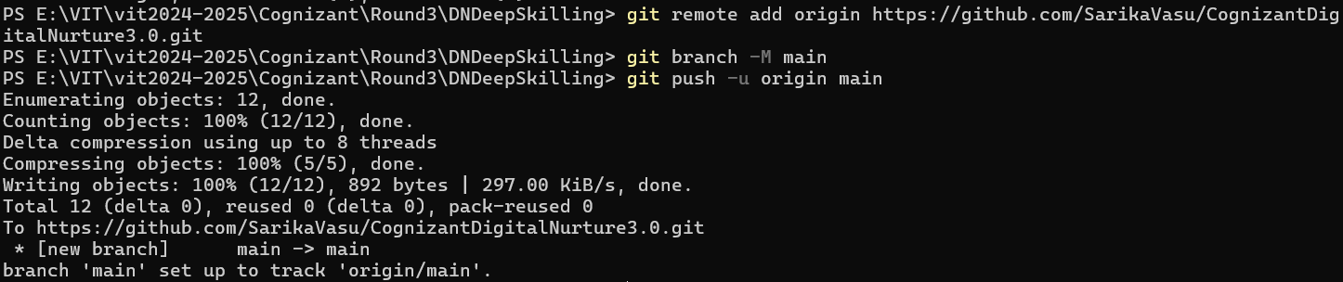

**Exercise 7: Collaborating with Git**

**Objective:**

Collaborate on a repository by creating a pull request.

**Instructions:**

1. Fork a repository on GitHub.
2. Clone your forked repository to your local machine.
3. Navigate into the cloned repository.
4. Create a new branch for your changes.
5. Make your changes and commit them.
6. Push the branch to your forked repository.
7. Create a pull request from your forked repository to the original repository.